# **CTF Topic: Linux Command**

# **Introduction**

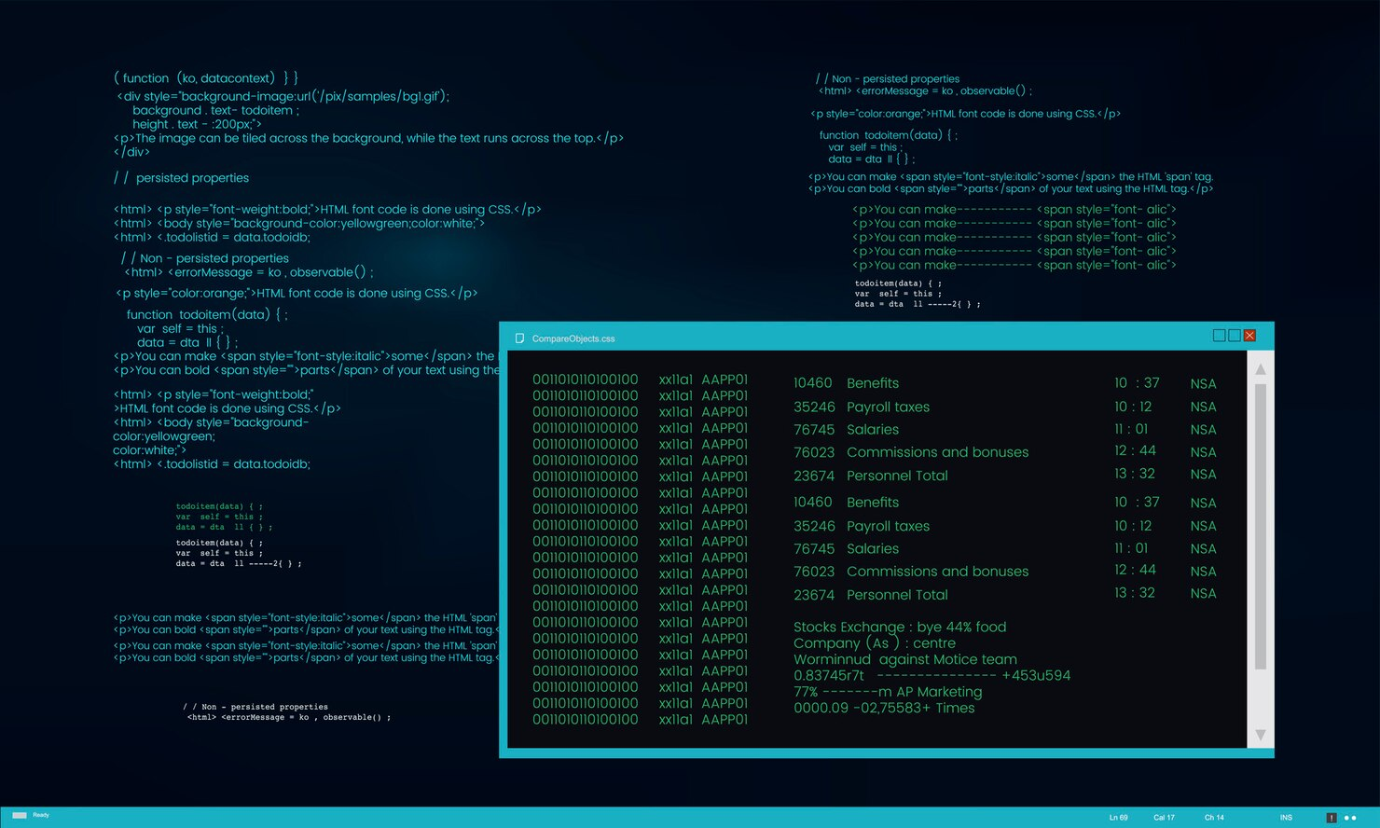

The Linux command line is a text-based interface to your computer, also known as the shell, terminal, or console. It allows you to interact with your system by typing commands and receiving output.

# **Scenario**

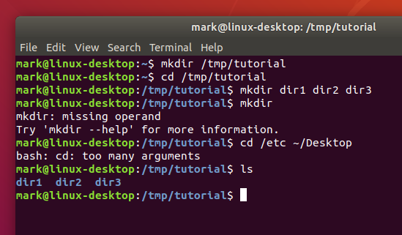

A student who recently completed their Secondary Education Examination (SEE) finds themselves intrigued by the world of computer systems, especially Linux and cybersecurity. With little to no prior knowledge in this field, they are uncertain about their future path after finishing their exams. Seeking to explore their newfound interest, they decide to enroll in an institute dedicated to computer education.To lay a solid foundation, their tutor at the institute assigns them a beginner-level Capture The Flag (CTF) challenge created by the renowned ING Group. Eager to embark on this learning journey, the student eagerly begins tackling the task, determined to grasp the basics of Linux systems and cybersecurity.

# **Process to Perform**

Step 1: Gather the information by research on the web

# **Let’s start the Challenge**

# **Question**

**Flag 1: Which command shows the current working directory?**

**Answer: pwd**

**Flag Captured.**

**Flag 2: Which command creates the directory?**

**Answer: mkdir**

**Flag Captured.**

**Flag 3: Which command lists the files and folders in the directory you are in?**

**Answer: ls**

**Flag Captured.**

# **Hint**

